2. Lec: Introduction To HTML

HTML (Hypertext Markup Language) plays a fundamental role in Web Development by providing the foundation for creating web pages. So, HTML is like the building blocks of a web page.

HTML is like the blueprint of a webpage. It defines the basic structure, telling the browser how to organize various elements on the page.
- HTML helps you put text on your webpage.
- HTML gives you the power to make lists.
- HTML lets you create links.
- HTML allows you to create tables.
- HTML also helps you show off pictures on your webpage.
Structure of basic HTML page
Just like the human body has structure and different parts in it. HTML also has structure.
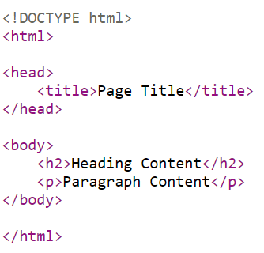
As you can observe HTML also has head, body and many more parts or sections in it. These are defined using a special keyword called as tag, just like your mathematics has rules and formulas.
Note: The <!DOCTYPE> declaration is not required when using the Wizklub.com platform.

What are opening and closing tags in HTML?
An opening tag in HTML is used to define the beginning of an HTML element. It consists of the element name being enclosed in angle brackets
(< >).

A closing tag in HTML marks the end of an HTML element. It is similar to the opening tag but includes a forward slash (/) before the element name.

For example: In <p>This is a paragraph </p>. The <p> is the opening tag, marking the start of the paragraph element, and </p> is the closing tag, signifying its end.
Together, opening and closing tags define the boundaries of HTML elements, allowing browsers to interpret and display content correctly.

1. Html Tag
- The <html> tag defines the document as a web page. It also specifies the beginning and end of the HTML document.
- All tags are nested between the <html> and </html>
Syntax:
<html>Content</html>
2. Head Tag
- Just as the head is vital for the human body by providing structure and control, the <body> tag is essential in HTML documents.
- Similarly, the <head> tag in an HTML document contains crucial information about the webpage, including tags like <title>, <meta>, and <link>, much like the sensory organs in a human head.
Syntax:
<head>
<title>Webpage Title</title>
</head>
3. Title Tag
- As the name suggests, the <title> tag specifies the title of the web page.
- This tag is described inside the head tag.
- The content in between the <title>…</title> tag appears on the tab or title bar in the browser window.
Syntax:
<title>Webpage Title</title>
4. Body Tag
- Just as the human body contains various organs that control different functions, the HTML <body> section includes all the visible content on a webpage.
- Images, links, text, and videos are placed between the <body> and </body> tags.
- It also contains other tags like <p> for paragraphs, <img> for images, and <ol> for ordered lists.
Syntax:
<body> Content </body>
Next, design a simple structure of a webpage using essential tags in the order they are used and write it down in your activity booklet
5. Paragraph tag
- The HTML element <p> defines a paragraph.
- Anything mentioned within <p> and </p> is treated as a paragraph.
- A paragraph is a block-level element, so a new paragraph always begins on a new line, and browsers naturally put some space before and after a paragraph to make it look neat and easy to read.
Syntax:
<p> paragraph of text </p>
Simple program to illustrate paragraph tag,
Example Program:
<html>
<body>
<p>Website is a collection of many Webpages </p>
<p>Webpage defines structure</p>
<body>
</html>
6. Heading tag:
- The heading tag is used in HTML to define headings of a page.
- HTML provides six levels of heading elements, ranging from <h1> (highest level) to <h6> (lowest level).
Syntax:
<h1> Main heading</h1>
<h2> subheading </h2>
<h3> small heading </h3>
<h4> small heading </h4>
<h5> small heading </h5>
<h6>small heading</h6>
Example Program :
<html>
<body>
<h1>Welcome to Web page</h1>
<h2>Home page</h2>
<h3>contact us</h3>
<h4>About us</h4>
<h5>more info</h5>
<h6>links to refer</h6>
<p>Website is a collection of many Webpages </p>
<p>Webpage defines structure</p>
</body>
</html>

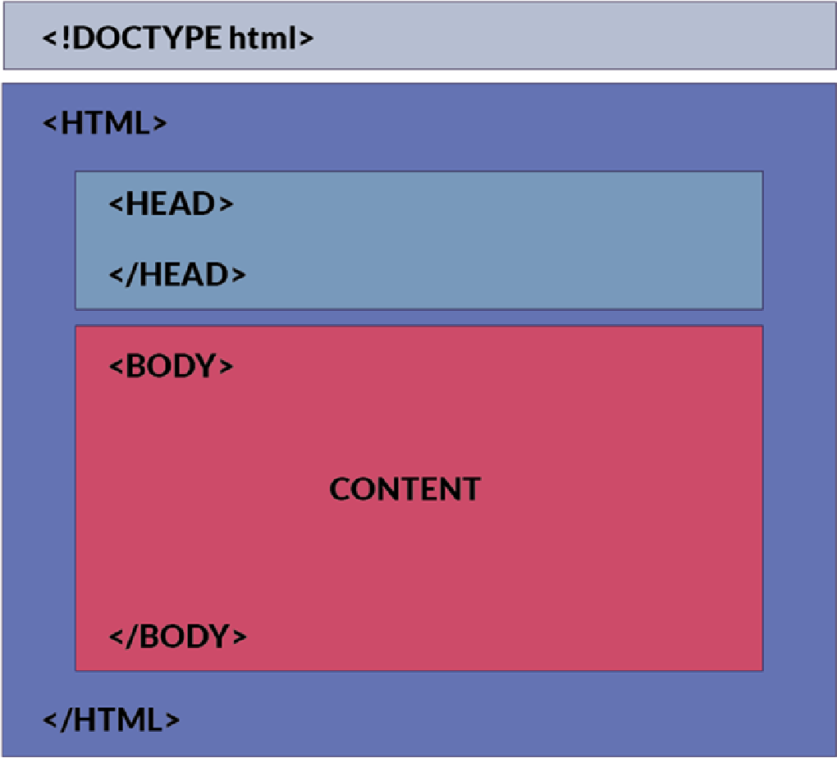

et's start by creating a HTML file
Steps to create a HTML file:
Step1: Click on + icon in Project files section.
Step 2: A window will be displayed to create a new file, give file name as index.html and select root folder and click create file.
Step 3: Click on index.html to open the file.
Step 4: Type your code in workspace and then click on save and deploy.
To view the output, click on the preview panel icon present at the bottom corner of the screen.
Follow the steps:
Step 1: Open the index.html
Step 2: Write the code.
<html>
<head>
<title> weather station</title>
</head>
<body>
<h1> Wiz Weather Station</h1>
<h3>Weather Station Parameters are</h3>
</html>

